Name : Maskur Al Shal Sabil
ID : IT18021
Topic : Linux Networking tool

Command-1 ping

PING (Packet Internet Groper) command is used to check the network connectivity between host and server/host. This command takes as input the IP address or the URL and sends a data packet to the specified address with the message “PING” and get a response from the server/host this time is recorded which is called latency. Fast ping low latency means faster connection. Ping uses ICMP(Internet Control Message Protocol) to send an ICMP echo message to the specified host if that host is available then it sends ICMP reply message. Ping is generally measured in millisecond every modern operating system has this ping pre-installed.
To get ping version installed in our system :
$ sudo ping -V
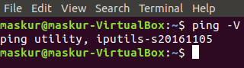

Using ping
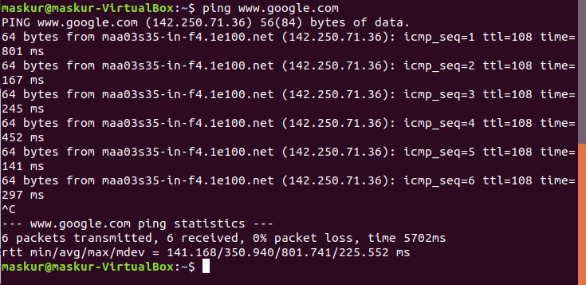

To stop pinging we should use ctrl+c otherwise it will continue .
In the last line
min: minimum time to get a response
- avg: average time to get responses
- max: maximum time to get a response
Controlling the number of pings:
We can define the number of packet sending to the server/host using -c
ping -c 3 www.google.com
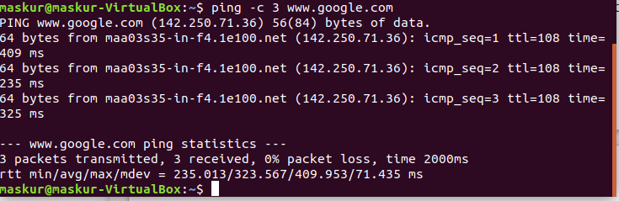
Where it will send only 3 packet .
Controlling the size of packets send:
The default size is 56 byte . We can control it using
-s option.
ping -s 40 -c 5 www.google.com
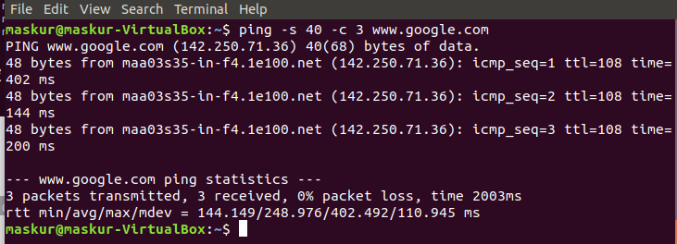
Changing the time interval:
By default ping wait for 1 sec to send next packet we can change this time by using -i option.
ping -i 4 www.google.com
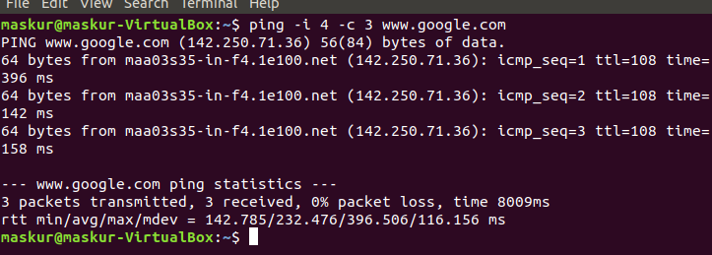
Now, the ping interval will change to 4 seconds
To get only summary:
To only get the summary about the network use -q option
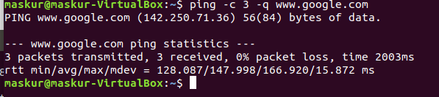
To Timout PING:
To stop pingig after sometime use -w option.
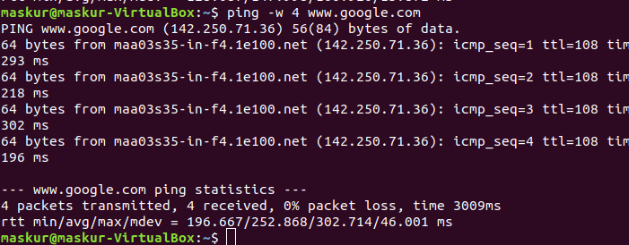
Flooding with PING:
To send packets as soon as possible. This is used to test network performance.
ping -f www.google.com
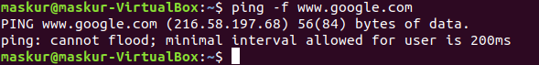
Specify TTL(Time To Live):
It is maximum hop a packet can travel before getting discarded.A value 0 will restricty packet to same host.
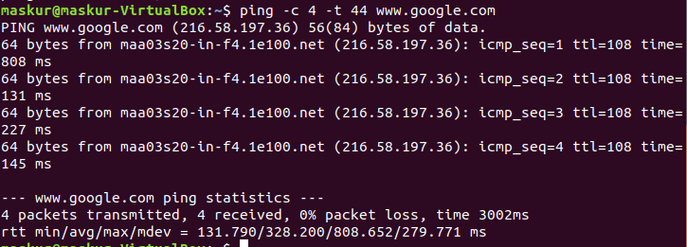

Command 2 - Curl
Linux curl command is used to download or upload data to a server via supported protocols such as HTTP, FTP, IMAP, SFTP, TFTP, IMAP, POP3, SCP, etc. It is a remote utility, so it works without user interaction.
The data transfer from one place to another is one of the vital and most used tasks of a computer system. However, there are many GUI tools available for data transfer. But, when working on the command-line, it becomes a bit complicated. The curl utility allows us to transfer data via the command line.

Syntax:
The basic syntax for using curl is as follows:
curl [options] [URL...]
URL : The most basic uses of curl is typing the command followed by the URL.
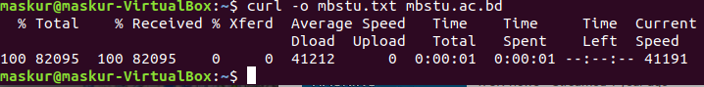
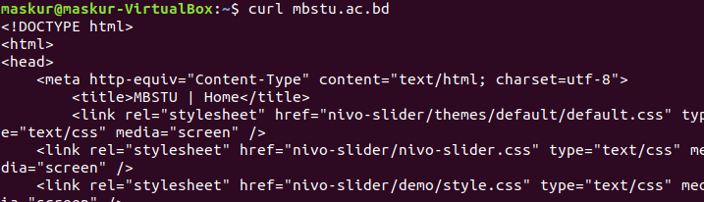
Now to save the html file we use the following command and save it in a text file mbstu.txt

To open the mbstu.txt file use : vim mbstu.txt
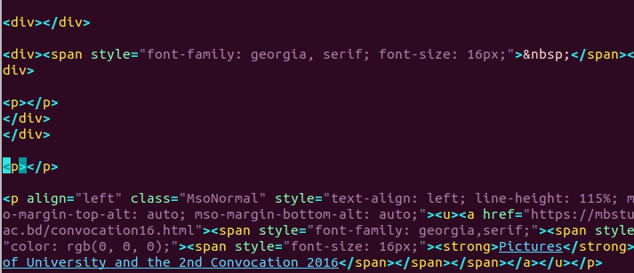

Get the HTTP Headers of a URL
HTTP headers are colon-separated key-value pairs containing information such as user agent, content type, and encoding. Headers are passed between the client and the server with the request or the response.
Use the -I option to fetch only the HTTP headers of the specified resource:

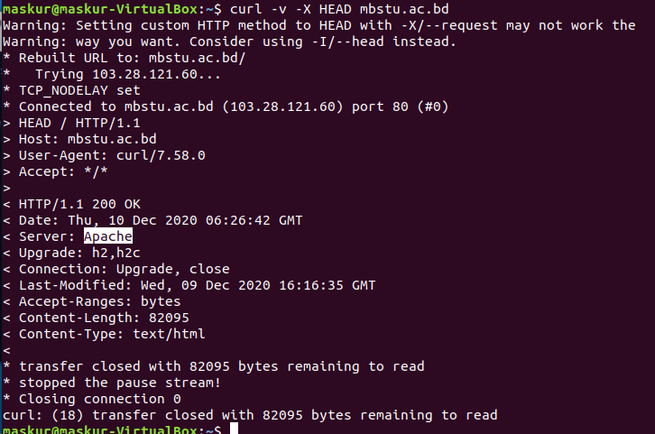
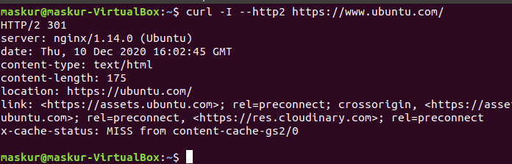

Follow Redirects
By default, curl doesn’t follow the HTTP Location headers.
If you try to retrieve the non-www version of google.com, you will notice that instead of getting the source of the page you’ll be redirected to the www version:
$ curl google.com
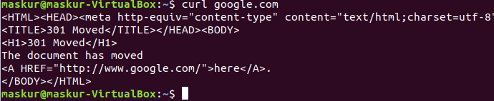
The -L option instructs curl to follow any redirect until it reaches the final destination:
$ curl -L google.com

Change the User-Agent
Sometimes when downloading a file, the remote server may be set to block the Curl User-Agent or to return different contents depending on the visitor device and browser.
In situations like this to emulate a different browser, use the -A option.
For example to emulates Firefox 60 we would use:

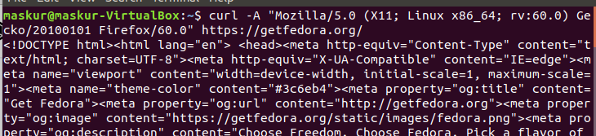

Specify a Maximum Transfer Rate
The --limit-rate option allows you to limit the data transfer rate. The value can be expressed in bytes, kilobytes with the k suffix, megabytes with the m suffix, and gigabytes with the g suffix.
In the following example curl will download the Go binary and limit the download speed to 1 mb:
curl --limit-rate 1m -O https://dl.google.com/go/go1.10.3.linux-amd64.tar.gz
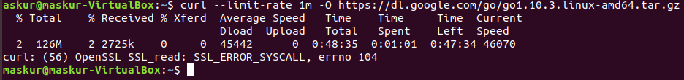
This option is useful to prevent curl consuming all the available bandwidth.

Transfer Files via FTP
To access a protected FTP server with curl, use the -u option and specify the username and password as shown below:
curl -u FTP_USERNAME:FTP_PASSWORD ftp://ftp.example.com/
Once logged in, the command lists all files and directories in the user’s home directory.
We can download a single file from the FTP server using the following syntax:
curl -u FTP_USERNAME:FTP_PASSWORD ftp://ftp.example.com/file.tar.gz
To upload a file to the FTP server, use the -T followed by the name of the file we want to upload:
curl -T newfile.tar.gz -u FTP_USERNAME:FTP_PASSWORD ftp://ftp.example.com/

Send Cookies
Sometimes we may need to make an HTTP request with specific cookies to access a remote resource or to debug an issue.
By default, when requesting a resource with curl, no cookies are sent or stored.
To send cookies to the server, use the -b switch followed by a filename containing the cookies or a string.
For example, to download the Oracle Java JDK rpm file jdk-10.0.2_linux-x64_bin.rpm we’ll need to pass a cookie named oraclelicense with value a:
curl -L -b "oraclelicense=a" -O http://download.oracle.com/otn-pub/java/jdk/10.0.2+13/19aef61b38124481863b1413dce1855f/jdk-10.0.2_linux-x64_bin.rpm
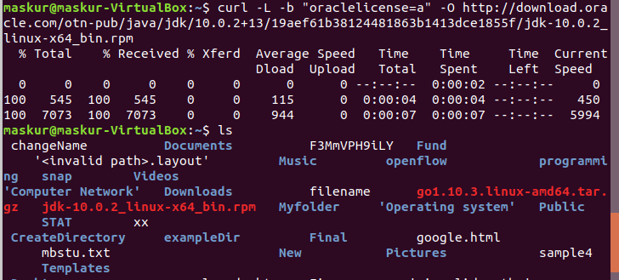

Using Proxies
curl supports different types of proxies, including HTTP, HTTPS and SOCKS. To transfer data through a proxy server, use the -x (--proxy) option, followed by the proxy URL.
The following command downloads the specified resource using a proxy on 192.168.44.1 port 8888:
curl -x 192.168.44.1:8888 http://linux.com/
If the proxy server requires authentication, use the -U (--proxy-user) option followed by the user name and password separated by a colon (user:password):
curl -U username:password -x 192.168.44.1:8888 http://linux.com/

Transfer Files via FTP
To access a protected FTP server with curl, use the -u option and specify the username and password as shown below:
curl -u FTP_USERNAME:FTP_PASSWORD ftp://ftp.example.com/
Once logged in, the command lists all files and directories in the user’s home directory.
We can download a single file from the FTP server using the following syntax:
curl -u FTP_USERNAME:FTP_PASSWORD ftp://ftp.example.com/file.tar.gz
To upload a file to the FTP server, use the -T followed by the name of the file you want to upload:
curl -T newfile.tar.gz -u FTP_USERNAME:FTP_PASSWORD ftp://ftp.example.com/

Command 3 – httpie
To install httpie use the following command
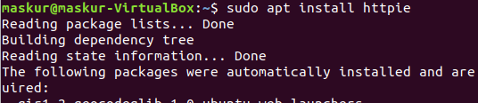
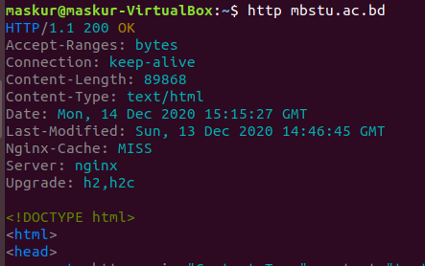

Query a website with HTTPie with get
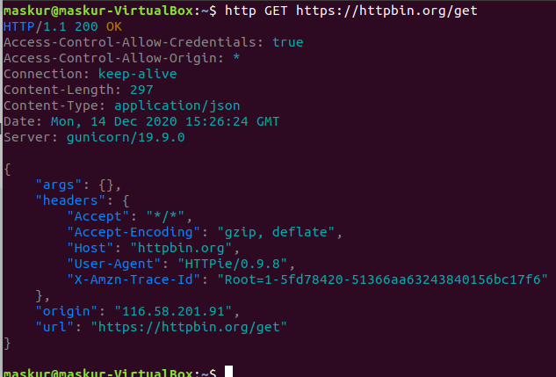
Httpbin.org provides options to set cookies (for testing purposes) through the URL path. The following sets a cookie titled name to the value maskur:
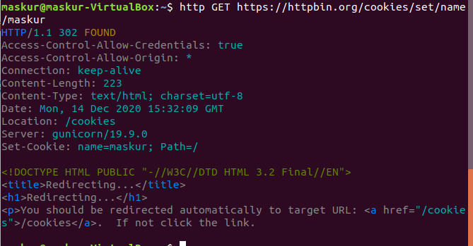
Notice the Set-Cookie: name=maskur; Path=/ header. This shows the cookie we expected to be set is set correctly and with a / path. Also notice that, even though we got a 302 redirect, http did not follow it. If we want to follow redirects, we need to ask for it explicitly with the --follow flag:

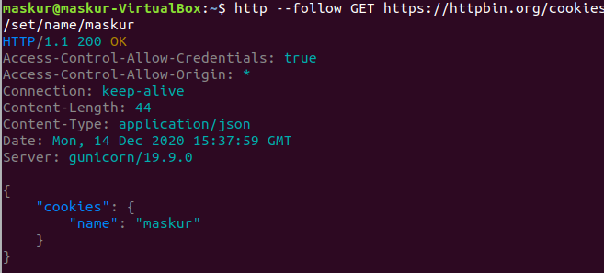
But now we cannot see the original Set-Cookie header. In order to see intermediate replies, you need to use –all:

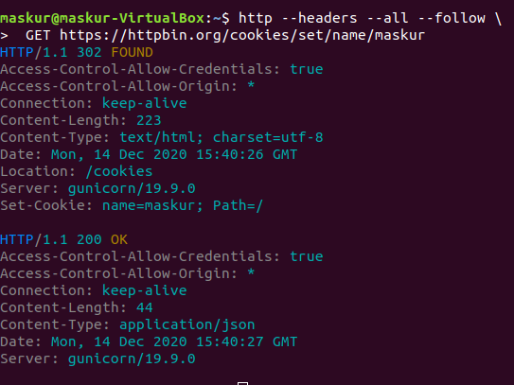
If we want to see the headers from the intermediate request but the body from the final request, we can do that with:

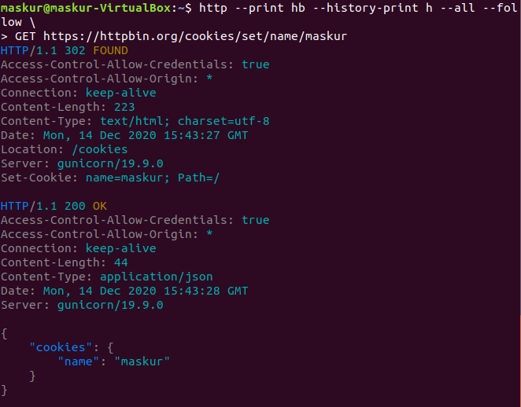
Sending custom requests with HTTPie
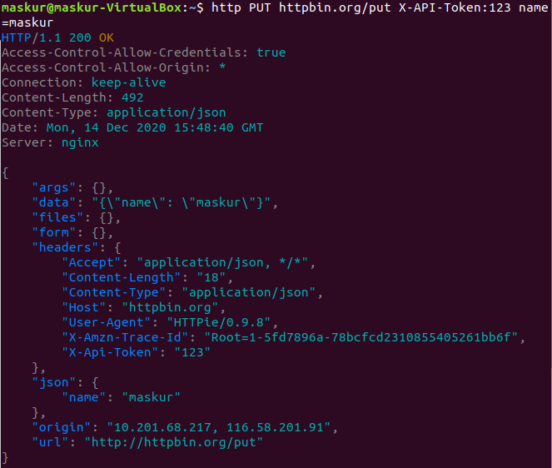
Custom http method, http headers and json data:

Submitting forms using post :
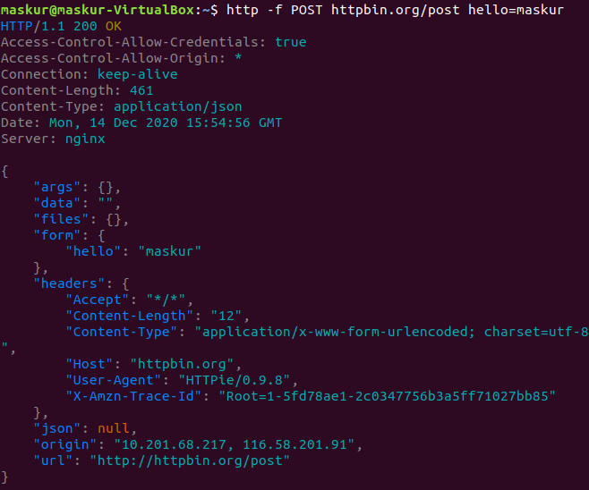
See the request that is being sent using one of the

